Brochure content (12-page brochure, A4 Portrait)

Recommended page allocation

1.Dr. ACS Aura – 2026-Attractive front cover
2.Welcome Message-Principal / Organising Chairman
3.About VTU-University profile
4.About Dr. ACSCE-Host institution profile
5.About the Athletic Meet-Objectives and highlights
6.Sporting Events-Track and field events
7.Programme Schedule-Four-day event timetable
8.Rules and Regulations-Eligibility and competition rules
9.Registration Guidelines-Entry and participation details
10.Venue and Facilities-Accommodation, transport and campus
11.Organising Committee-Dignitaries and subcommittees
12.Back Cover-Contact details and QR codes

DR. ACS AURA – 2026
VTU 28th State Level Inter-Collegiate Athletic Meet – 2026
7–10 December 2026
Hosted by: Dr. ACS College of Engineering, Bengaluru
Organised under: Visvesvaraya Technological University, Belagavi
Recommended format:
- Size: A4 portrait (210 × 297 mm).
- Pages: 12 pages (including front and back covers).
- Printing: Full-colour, premium 170 GSM art paper for inner pages and 250–300 GSM for the cover.
- Binding: Saddle stitch.
- Design colours: Navy blue, royal blue, gold, white and athletic red.
- Visual elements: Running track, athletes, medals, stadium, university and college logos.

PAGE 1 – Front Cover
Content to include:
VISVESVARAYA TECHNOLOGICAL UNIVERSITY, BELAGAVI
Dr. ACS Aura – 2026
VTU 28th State Level Inter-Collegiate Athletic Meet – 2026
Organised by
Dr. ACS College of Engineering
Under the aegis of Moogambigai Charitable and Educational Trust
An Autonomous Institution under VTU, Belagavi
Approved by AICTE, UGC & Government of Karnataka
DATE: 7th – 10th December 2026
VENUE: Dr. ACS College of Engineering Campus, Bengaluru.
Tagline:
Celebrating Athletic Talent, Sportsmanship, Determination and Excellence.
Bottom of cover:
- VTU Logo
- Dr. ACS College of Engineering Logo
- Website: www.acsce.edu.in
PAGE 2 – Welcome Message from the Organising Chairman

Title: Welcome to Dr. ACS Aura – 2026
This page should carry a welcome message from the Principal and Organising Chairman.
Suggested content:
It gives me immense pleasure to welcome all the participating institutions, distinguished dignitaries, university officials, faculty members, sports coordinators, coaches and talented athletes to the VTU 28th State Level Inter-Collegiate Athletic Meet – 2026, proudly hosted by Dr. ACS College of Engineering, Bengaluru.
Sports play a vital role in shaping individuals by promoting discipline, teamwork, leadership, perseverance and a spirit of healthy competition. Athletic competitions provide an excellent platform for young talents to demonstrate their physical abilities, determination and commitment to excellence.
Through Dr. ACS Aura – 2026, we look forward to bringing together talented athletes from engineering institutions across Karnataka, fostering friendship, unity and sportsmanship beyond institutional boundaries.
Our institution is honoured to host this prestigious university-level sporting event and is committed to providing a welcoming environment, quality facilities and excellent arrangements for all participants.
I extend my best wishes to every athlete and participating institution. May these four days of competition inspire new achievements, lasting friendships and unforgettable sporting memories.
Dr. B.S. Shylaja
Principal & Organising Chairman
Dr. ACS College of Engineering, Bengaluru.

PAGE 3 – About Visvesvaraya Technological University
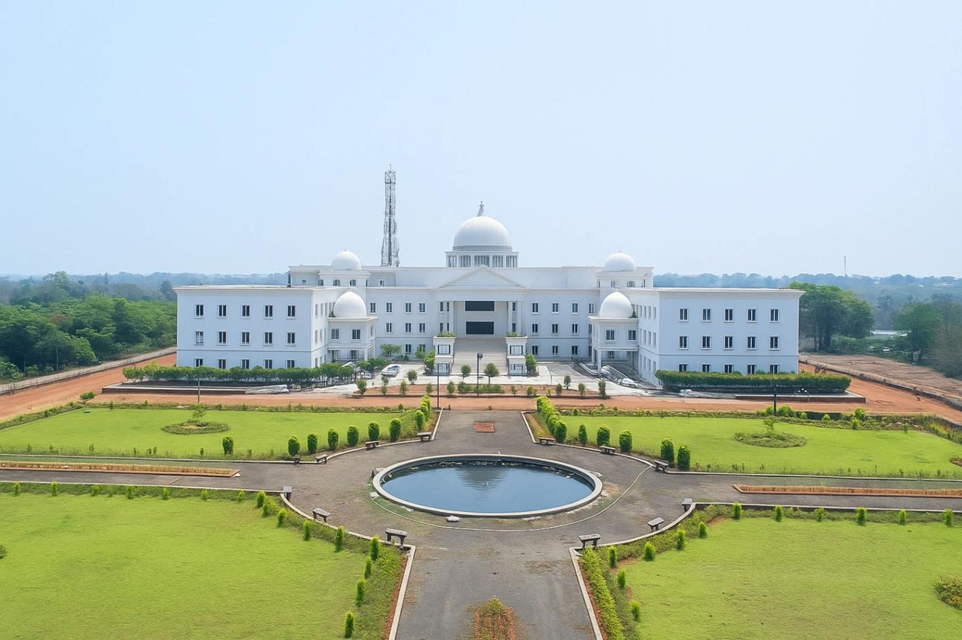
Title: About Visvesvaraya Technological University, Belagavi
Include:
- Brief history and establishment of VTU.
- VTU's role in technical education in Karnataka.
- Affiliated institutions across Karnataka.
- Commitment to academic excellence, research, innovation and holistic development.
- Promotion of sports, physical fitness and extracurricular activities among engineering students.
- Importance of inter-collegiate sporting competitions.
Suggested introductory paragraph:
Visvesvaraya Technological University (VTU), headquartered at Belagavi, Karnataka, is one of the premier technological universities in India, dedicated to advancing technical education, research, innovation and professional excellence. The University plays a significant role in nurturing engineering talent and promoting holistic student development through academic, technical, cultural and sporting activities.
The VTU Inter-Collegiate Athletic Meet is an important initiative that provides a common platform for students from affiliated institutions to demonstrate their sporting abilities, foster camaraderie and uphold the values of discipline, teamwork and sportsmanship.
PAGE 4 – About Dr. ACS College of Engineering
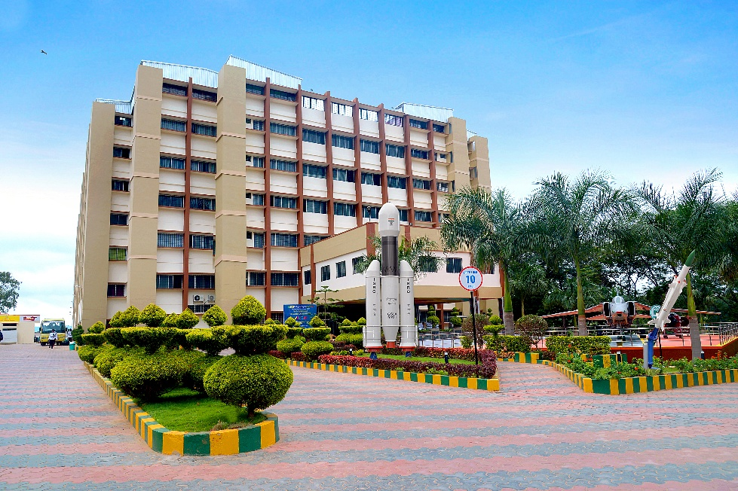
Title: About the Host Institution
Suggested content:
Dr. ACS College of Engineering, Bengaluru, established in 2009 under the Moogambigai Charitable and Educational Trust, is committed to providing quality technical education and fostering academic excellence, innovation, research and professional development.
The institution offers a conducive learning environment supported by experienced faculty members, modern infrastructure, advanced laboratories, industry collaborations and research facilities.
As an autonomous institution under Visvesvaraya Technological University, Belagavi, Dr. ACS College of Engineering continuously strives to promote academic excellence, entrepreneurship, innovation, leadership and holistic student development.
Beyond academics, the institution encourages students to participate in sports, cultural activities, technical competitions and community engagement initiatives.
Institutional highlights to showcase:
Particulars | Details
Established | 2009
Students | 1,440+
Industry & Academic MoUs | 25
Funded Research Projects | ₹1.75 Cr+
Placement Offers | 554+
Add:
- Accreditation and institutional recognition.
- Sports facilities and student development initiatives.
- Campus photographs.
- Website: www.acsce.edu.in.

PAGE 5 – About Dr. ACS Aura – 2026
Title: About the Athletic Meet
Suggested content:
Dr. ACS Aura – 2026, the VTU 28th State Level Inter-Collegiate Athletic Meet, is a prestigious sporting event bringing together student athletes from engineering institutions affiliated with Visvesvaraya Technological University, Belagavi.
Scheduled from 7th to 10th December 2026 at Dr. ACS College of Engineering, Bengaluru, the event aims to provide a competitive platform for young athletes to showcase their talent, endurance, speed, strength and sporting excellence.
The four-day athletic meet will celebrate the true spirit of sportsmanship while encouraging healthy competition, mutual respect, teamwork and the pursuit of excellence.
Objectives of the Meet
- To promote sports culture and physical fitness among engineering students.
- To identify and encourage emerging athletic talent.
- To provide a competitive platform for university-level athletes.
- To foster unity and interaction among VTU-affiliated institutions.
- To inculcate discipline, leadership and team spirit.
- To encourage participation, inclusivity and excellence in sports.
Event highlights:
- Four days of athletic competitions.
- Participation from VTU-affiliated engineering colleges.
- Track and field competitions.
- Recognition of outstanding athletic performances.
- Medals, certificates and trophies for winners.
- Celebration of sporting excellence and camaraderie.

PAGE 6 – Athletic Events and Competition Categories
Title: Sporting Events
This is one of the most important pages. Present the events in a visually appealing table or category-wise layout.
A. Track Events
Sl. No. | Events
1 | 100 m
2 | 200 m
3 | 400 m
4 | 800 m
5 | 1500 m
6 | 5000 m
7 | 10000 m
8 | 110 m / 100 m Hurdles
9 | 400 m Hurdles
10 | 4 × 100 m Relay
11 | 4 × 400 m Relay
B. Field Events
Sl. No. | Events
1 | Long Jump
2 | High Jump
3 | Triple Jump
4 | Pole Vault
5 | Shot Put
6 | Discus Throw
7 | Javelin Throw
8 | Hammer Throw
C. Separate Categories
- Men's Events
- Women's Events
Important: The above is a proposed event list for brochure planning. Finalise the events, age/eligibility requirements, categories and competition format strictly according to the official VTU 2026–27 athletic meet circular.
PAGE 7 – Event Schedule / Programme
Title: Four Days of Sporting Excellence

Provide the detailed event schedule with dates, timings and event names.

Suggested layout:
Date Programme
7 December 2026 Reporting, registration, verification and inaugural ceremony; scheduled competitions
8 December 2026 Track and field competitions
9 December 2026 Track and field competitions
10 December 2026 Final events, closing ceremony and prize distribution

Additional information to include:
- Reporting time for participating teams.
- Team manager meeting.
- Inauguration and flag hoisting.
- Competition commencement.
- Lunch and refreshment breaks.
- Medal distribution.
- Valedictory ceremony.

PAGE 8 – Rules and Regulations
Title: General Rules and Regulations
This page is essential for team managers, coaches and participating athletes.
Include the following sections:
1. Eligibility
- Only eligible students from VTU-affiliated institutions may participate, subject to university regulations.
- Participants must produce valid institutional identity cards.
- Eligibility shall be verified by the organising committee.

2. Registration
- Participating colleges must submit entries within the stipulated deadline.
- Final entries must be approved by the concerned authorities.
- Team managers shall be responsible for the correctness of participant details.
3. Reporting
- Athletes must report to the event venue well before the scheduled competition.
- Late reporting may result in disqualification as per competition rules.
- Bib numbers must be displayed appropriately.
4. Competition Rules
- Events will be conducted in accordance with the applicable VTU and athletics competition regulations.
- Decisions of the technical officials and jury shall be final, subject to prescribed appeal procedures.
- Athletes must follow the instructions of the organising committee.
5. Discipline and Sportsmanship
- All participants must maintain discipline and decorum.
- Misconduct or unsportsmanlike behaviour may attract disciplinary action.
- Athletes must respect officials, opponents and fellow participants.
6. Safety
- Appropriate sportswear and footwear are mandatory.
- Participants must follow safety instructions.
- Any injury or medical emergency must be immediately reported.
The final rulebook should be based on the official VTU circular and applicable Athletics Federation of India regulations.

PAGE 9 – Registration and Participation Guidelines
Title: Participation and Registration
Include a step-by-step registration process.
Step 1 – Institutional Registration
Participating colleges should nominate their teams through their respective Principals/Physical Education Directors.
Step 2 – Submission of Entries
Submit the prescribed entry forms containing:
- College name and address.
- Name of Principal.
- Name of Physical Education Director / Team Manager.
- Athlete details.
- University registration numbers.
- Selected events.
- Contact details.
Step 3 – Document Verification
Participants should bring:
- College identity card.
- VTU registration details.
- Eligibility certificate, if prescribed.
- Medical fitness certificate, if required.
- Approved entry form.
Step 4 – Reporting and Bib Collection
Team managers must complete registration and collect participant bib numbers at the designated registration counter.
Registration details to publish:
Particulars | Information
Registration start date | To be announced
Last date for entries | To be announced
Mode of registration | As per VTU instructions
Reporting venue | Dr. ACS College of Engineering
Team manager contact | To be provided
Include a QR code for online registration, if an official registration link is available.

PAGE 10 – Venue, Facilities and Accommodation
Title: Venue and Participant Facilities
Venue:
Dr. ACS College of Engineering
No. 207, Kambipura, Mysore Road,
Bengaluru – 560074, Karnataka.
Include the following information:
Facilities for Participants
- Athletic competition venue.
- Registration and help desk.
- Drinking water facilities.
- Resting and waiting areas.
- First-aid and medical assistance.
- Washroom facilities.
- Refreshment and food arrangements, as applicable.
Accommodation
Mention:
- Accommodation availability and arrangements.
- Details of nearby accommodation.
- Booking procedure.
- Charges, if applicable.
- Contact person for accommodation.
Transportation
- Nearest railway station.
- Nearest bus terminal.
- Airport connectivity.
- Campus access and local transportation.
Include a Google Maps QR code and a campus location map.

PAGE 11 – Organising Committee and Officials
Title: Organising Committee
This page should give prominence to the institutional leadership and the people responsible for conducting the event.
Suggested hierarchy:
Designation | Name
Chief Patron | Chairman / Management Representative
Patron | Principal, Dr. ACS College of Engineering
Organising Chairman | Dr. B.S. Shylaja, Principal
Organising Secretary | Mr. Devendra Naik, Physical Education Director
Event Coordinator | Dr.Suresha, Professor, Dr.ACSCE
VTU Sports Coordinator | As nominated by VTU
Subcommittees to include:
- Reception and Hospitality Committee.
- Registration and Accreditation Committee.
- Technical and Events Committee.
- Ground and Infrastructure Committee.
- Accommodation and Transportation Committee.
- Food and Refreshment Committee.
- Medical and First-Aid Committee.
- Finance and Purchase Committee.
- Publicity and Media Committee.
- Discipline and Security Committee.
- Awards and Certificates Committee.
- Photography and Documentation Committee.
For each committee, include the convener and members' names.
include the names of:
- VTU sports officials.
- Technical officials and referees.
- Chief guests and dignitaries.
- College management representatives.

PAGE 12 – Back Cover / Contact Information

DR. ACS AURA – 2026
Let the Games Begin!
Sport | Spirit | Excellence
We look forward to welcoming athletes, sports officials, team managers and participating institutions to Bengaluru for four days of sporting excellence.
Organised by
Dr. ACS College of Engineering
Moogambigai Charitable and Educational Trust
No. 207, Kambipura, Mysore Road, Bengaluru – 560074.
Contact Persons
Organising Chairman
Dr. B.S. Shylaja
Principal, Dr. ACS College of Engineering.
Organising Secretary
Mr. Devendra Naik
Physical Education Director
Mobile: 8088891143
Website: www.acsce.edu.in
Email: sports@acsce.edu.in
Include:
- VTU and college logos.
- QR code for website.
- QR code for Google Maps.
- Social media handles, if applicable.

